120″ Primary Mirror Washing
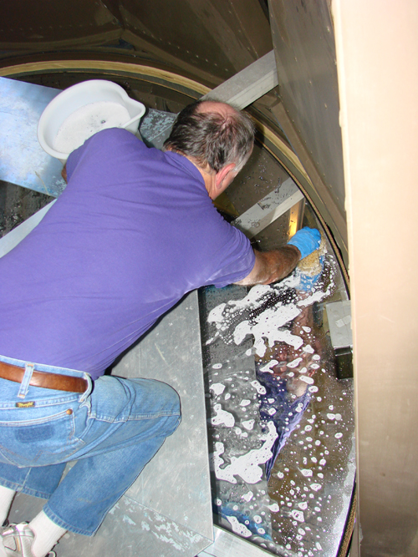
Introduction: The 120″ primary should be washed on an annual basis. Because this procedure requires the removal of the secondary cage and central baffle or third mirror it is best to conduct this operation during a regularly scheduled focus change. Preferably a change going to Coude′ so the bottom of the telescope is clear of instruments and there are no time constraints for working in the dome (no dark exposures).

Safety: Follow normal safety procedures for focus changes though you may want to cordon off an area of floor under and a bit wider than the telescope so passers by will not be hit by discarded blotters and wipes as cleaning progresses.

Setting Up: A couple of days ahead of time you should gather your supplies for the washing to make sure you have what you need to complete the washing.
The supplies needed are as follows:  - Knee pads  - Two pails of “Orvis Wash Water” in plastic pails.  - Two natural sea sponges to use as nonabrasive cleaning pads.  - Several 5gal water bottles filled with distilled water.  - Stainless steel pressure vessel and associated hoses and regulator used for wetting and rinsing the mirror with distilled water.  - Several boxes of low lint K-Dry wipes.  - Reflectometer for testing the mirror before and after washing. The batteries should also be checked.  - Air hose connected to spectrograph air supply for inflating the sealing tube on the drain adapter.  - Drain Adapter  - Squirt bottle of acetone for cleaning oil spots on the mirror.  - Blotter paper on a cart for ease of handling. | 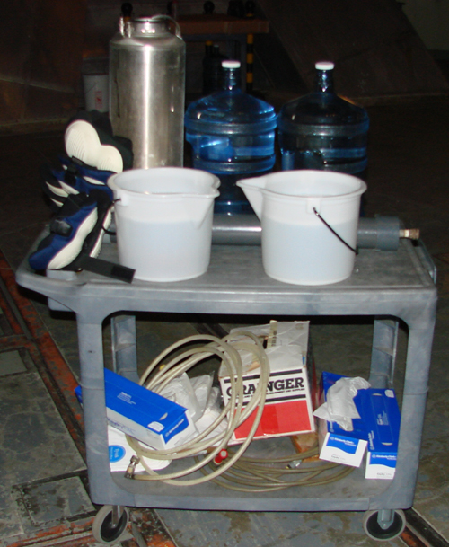  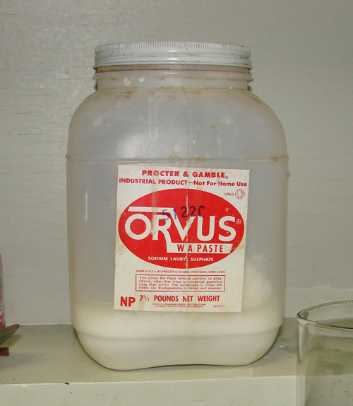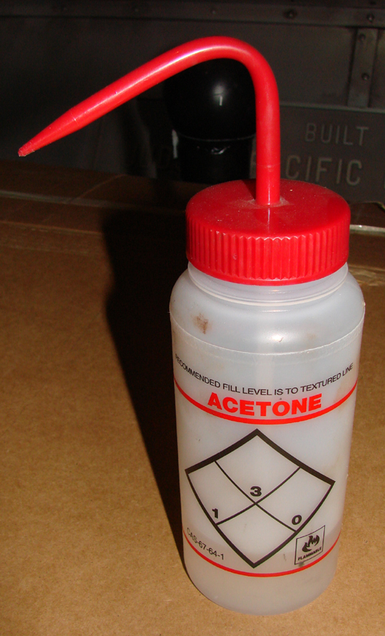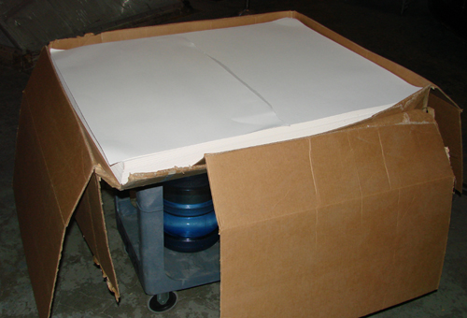
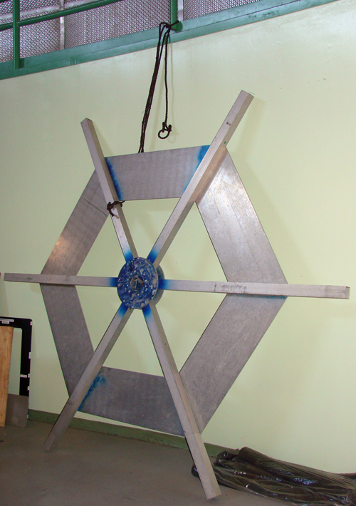
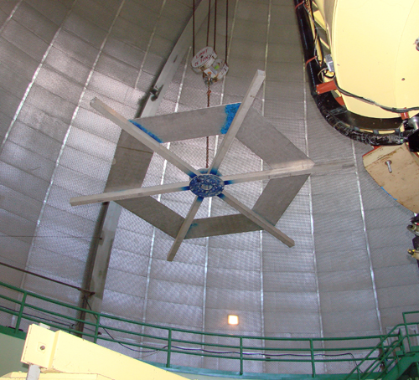
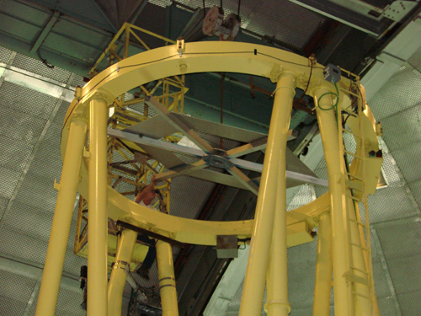
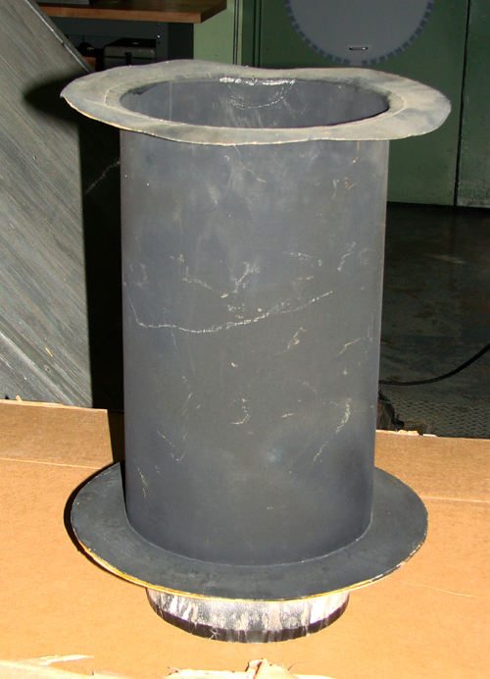
On the appointed day of washing start the focus change up to the point where you have removed and parked the central light baffle. Then grab a chain and hook it onto the washing platform that is tied-off to the handrail somewhere against the wall on the mezzanine. Lift this platform and place it in the center of the telescope about six feet above the mirror cover (still closed at this time for safety). Getting the platform into the telescope tube assembly is a little tricky as the platform legs radiate out to a larger diameter than the top ring on the telescope. Someone must be at the top of the telescope to tip and lower the platform through the ring. A second point of restriction is just before the box section of the telescope tube with the two suspended light baffles north and south and then at the box section where the platform must be manipulated to pass through to below the box section. At this point the mirror cover can be opened and the platform seated between the leaves of the cover. Just a little before the platform is seated the mirror central light baffle (top hat) must be removed.
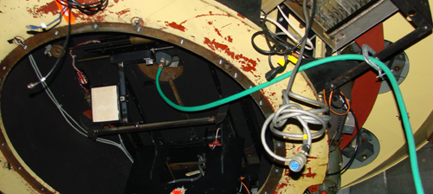
Under the telescope inside the tub you route the garden hose (used as a waste water drain from washing the mirror) up to the inflatable drain adapter. The hose discharge end goes into one of the darkroom sinks or the janitors sink in the hallway near the electronics shop.

